Laboratory work 2
DDL
Create tables and define Primary Keys for each table + Define for all attributes not null constraint
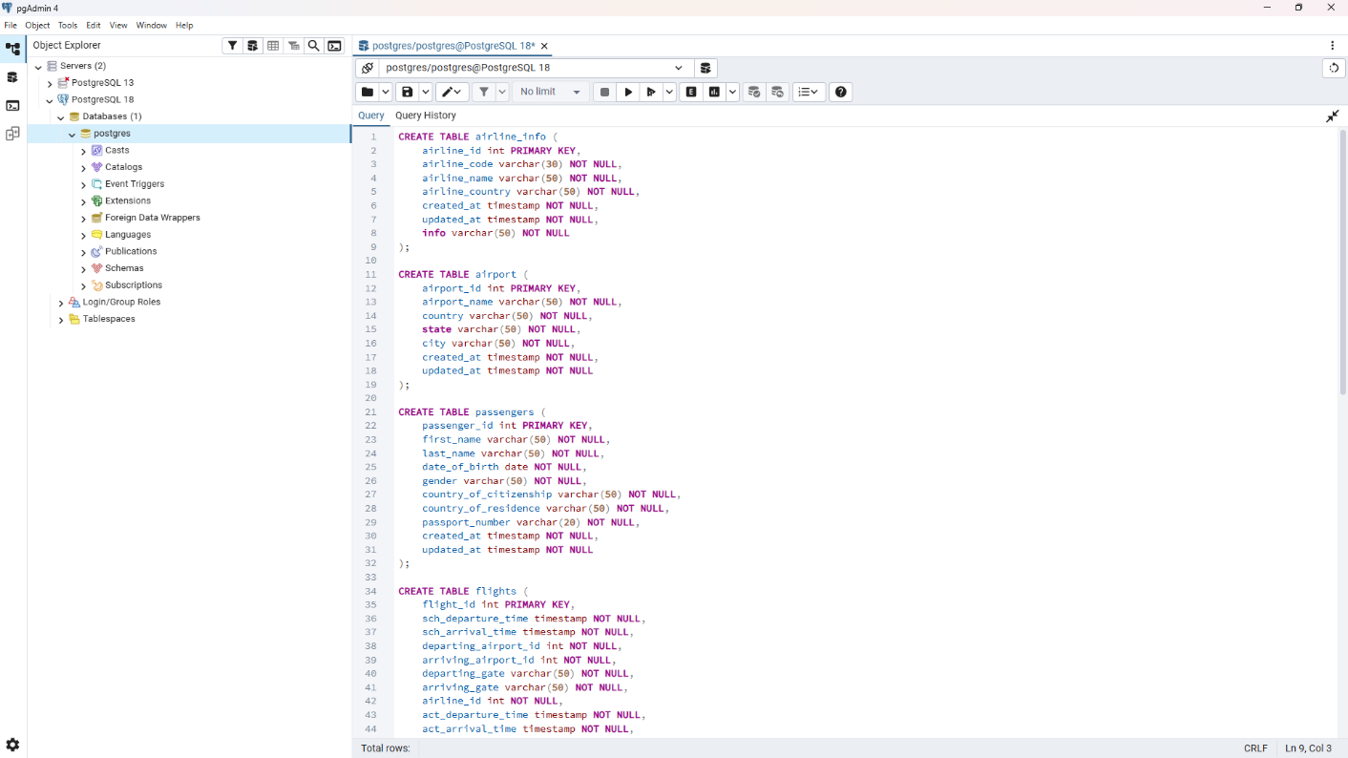
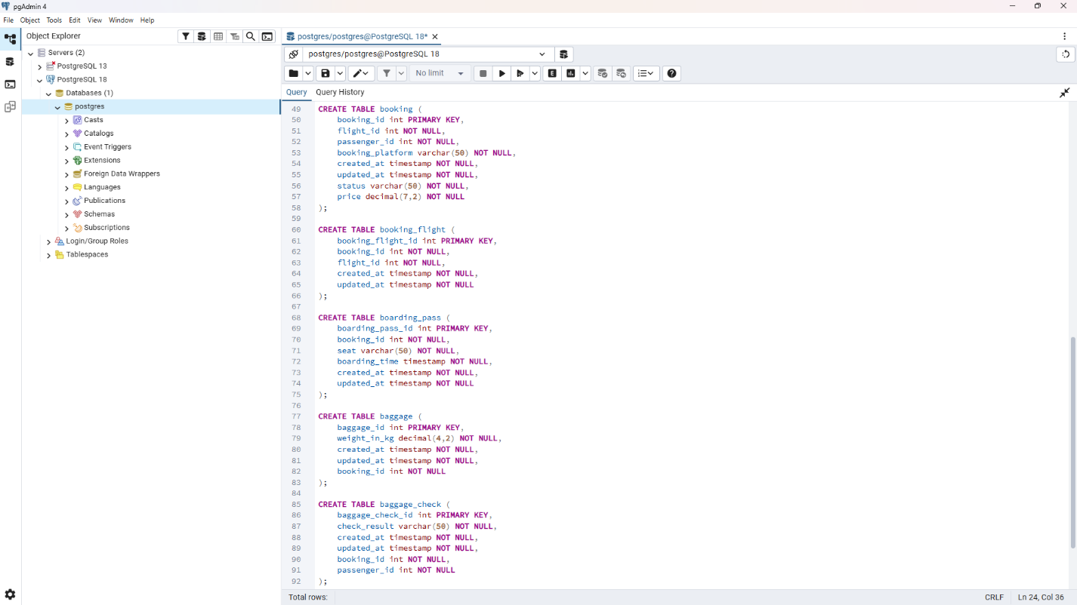

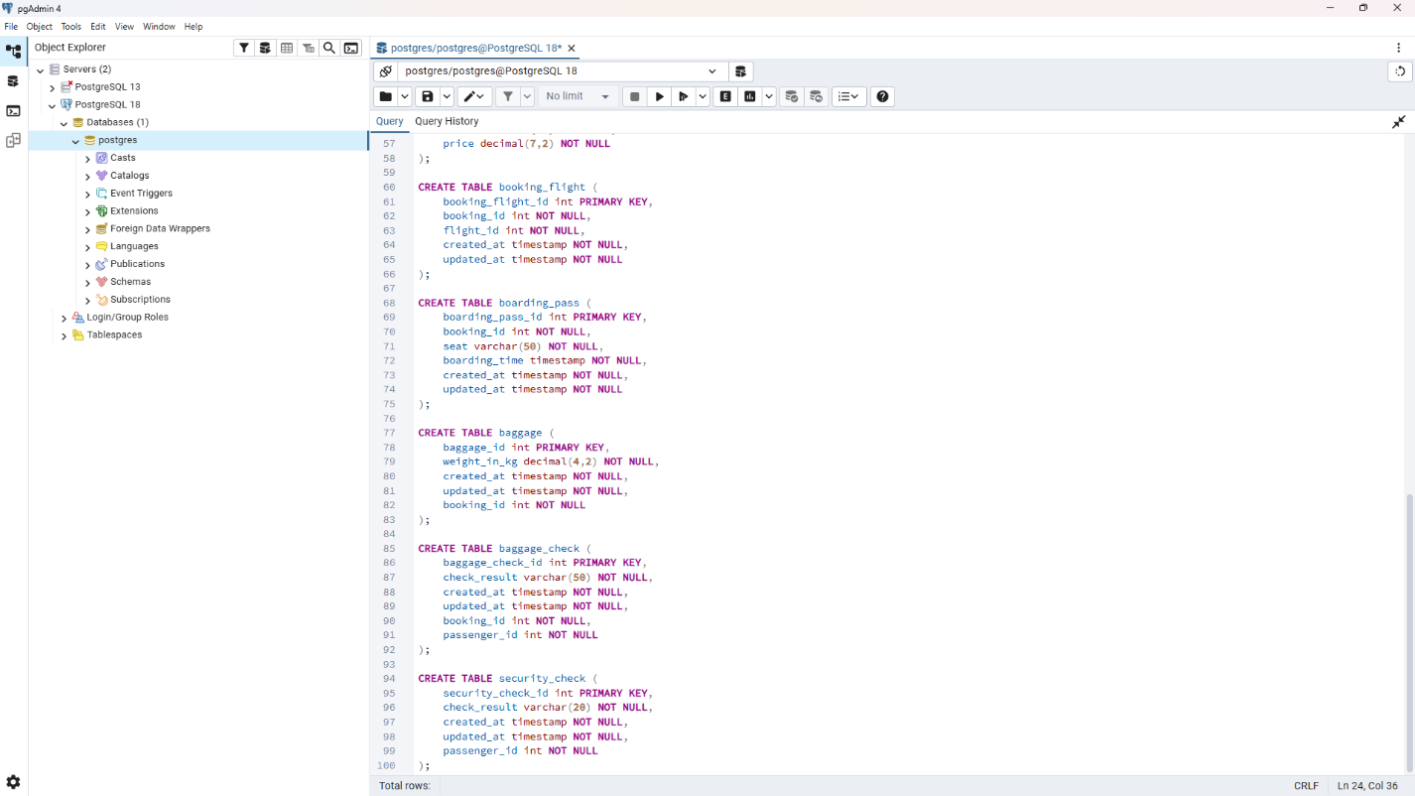
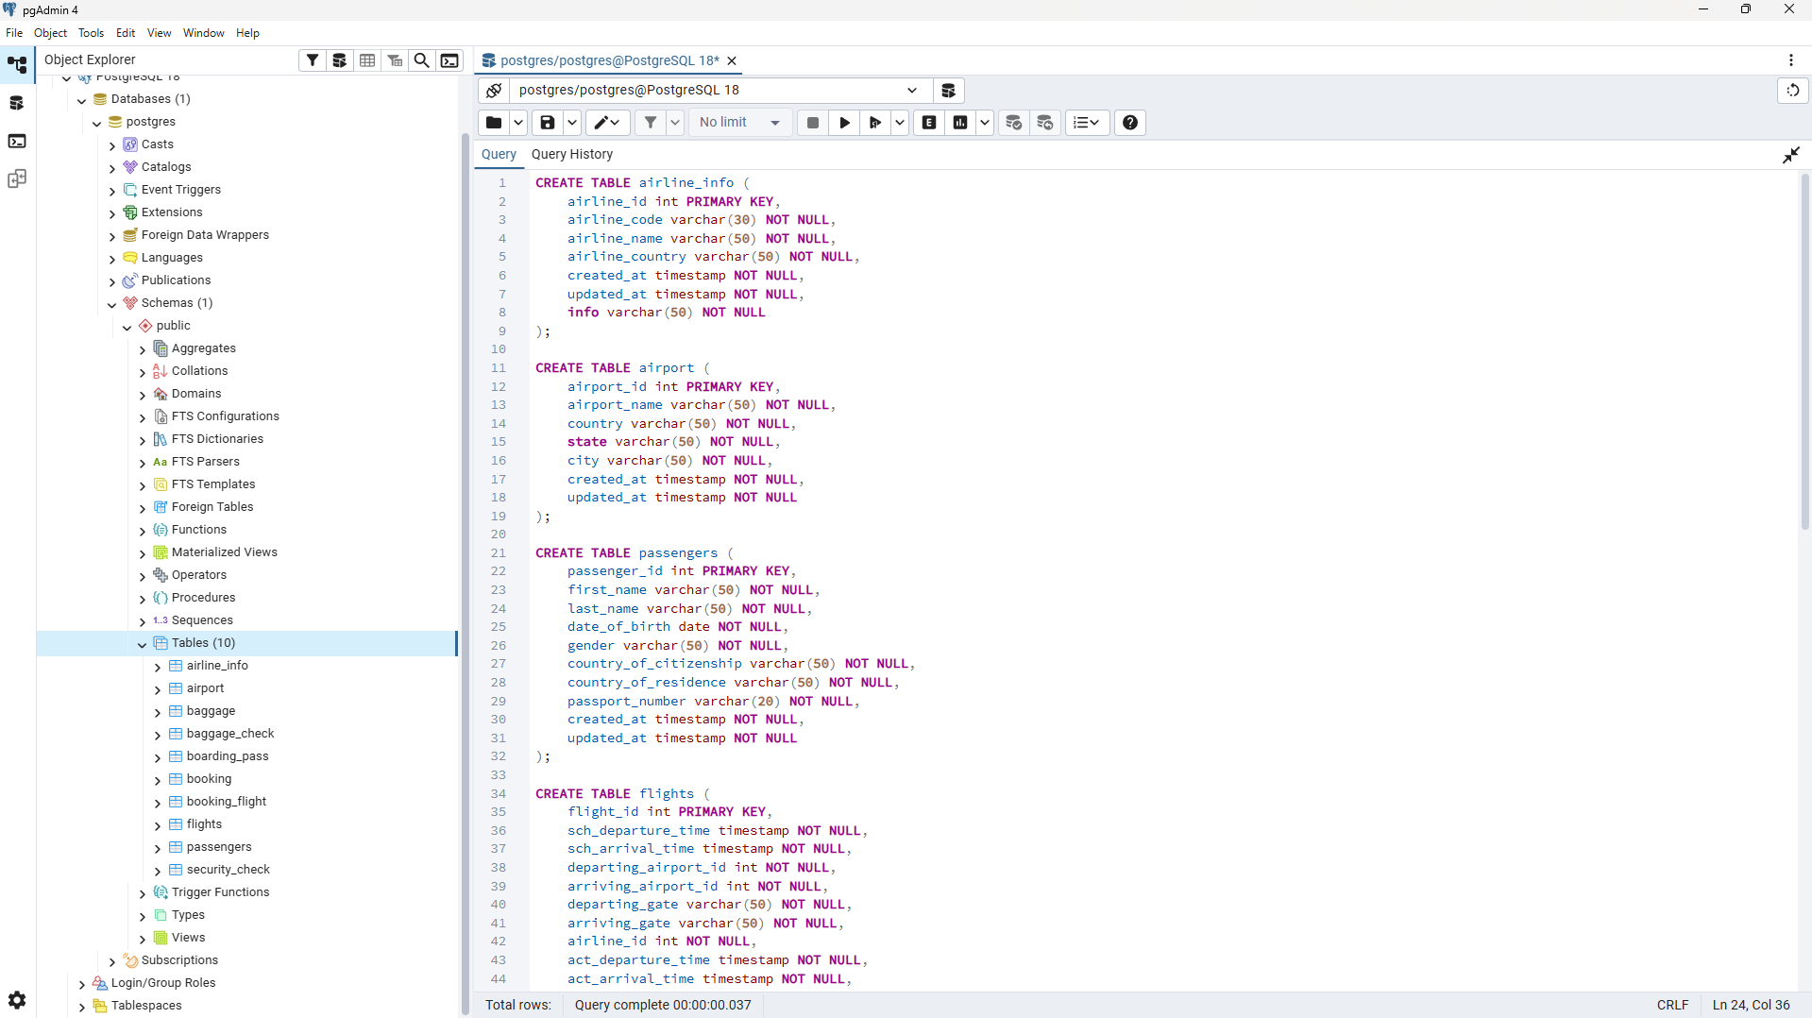All tables created

Rename airline_info table to airline;
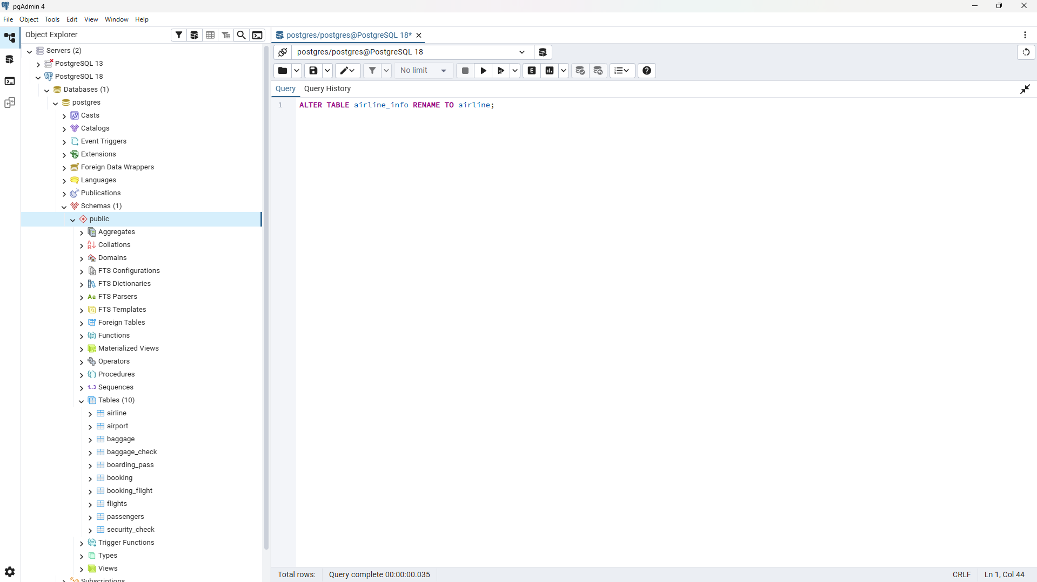
Rename column price to ticket_price in booking table
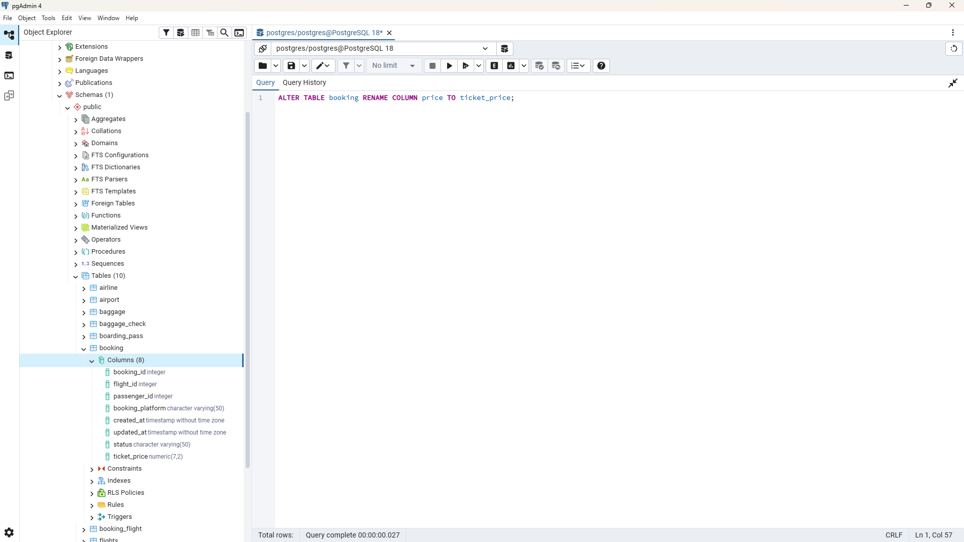
Change data type of departing_gate from varchar(50) to text
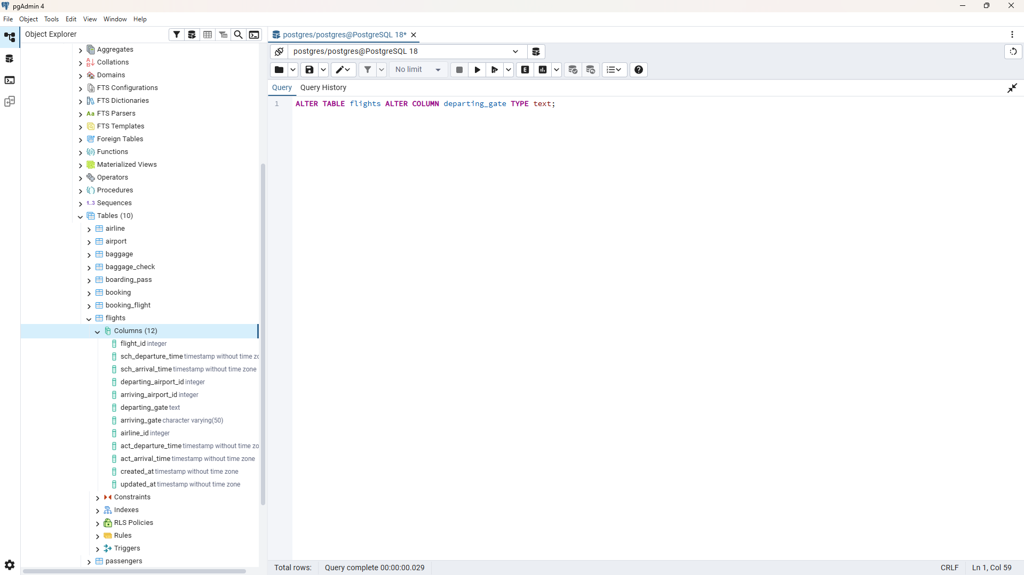

Drop the column info(varchar(50)) from the airline table.
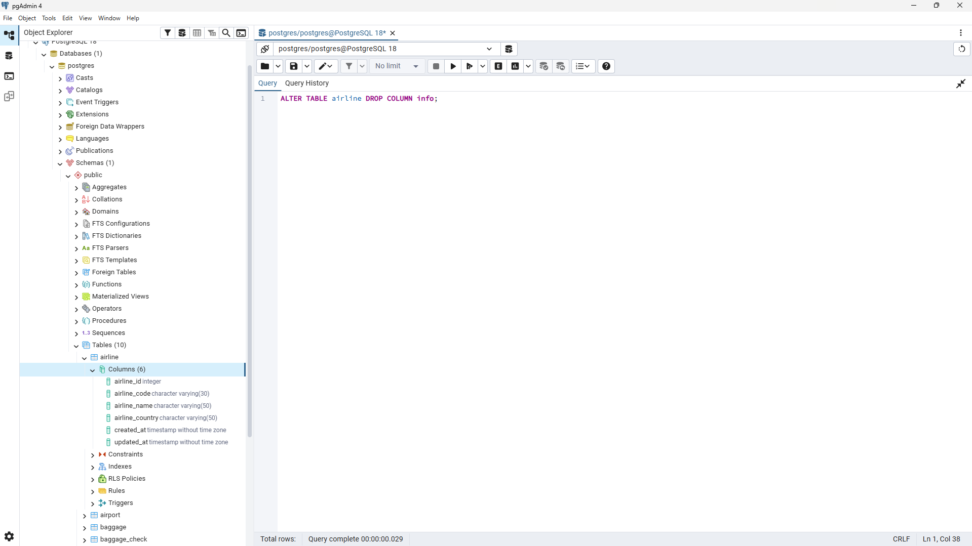
Make a relationship between following tables
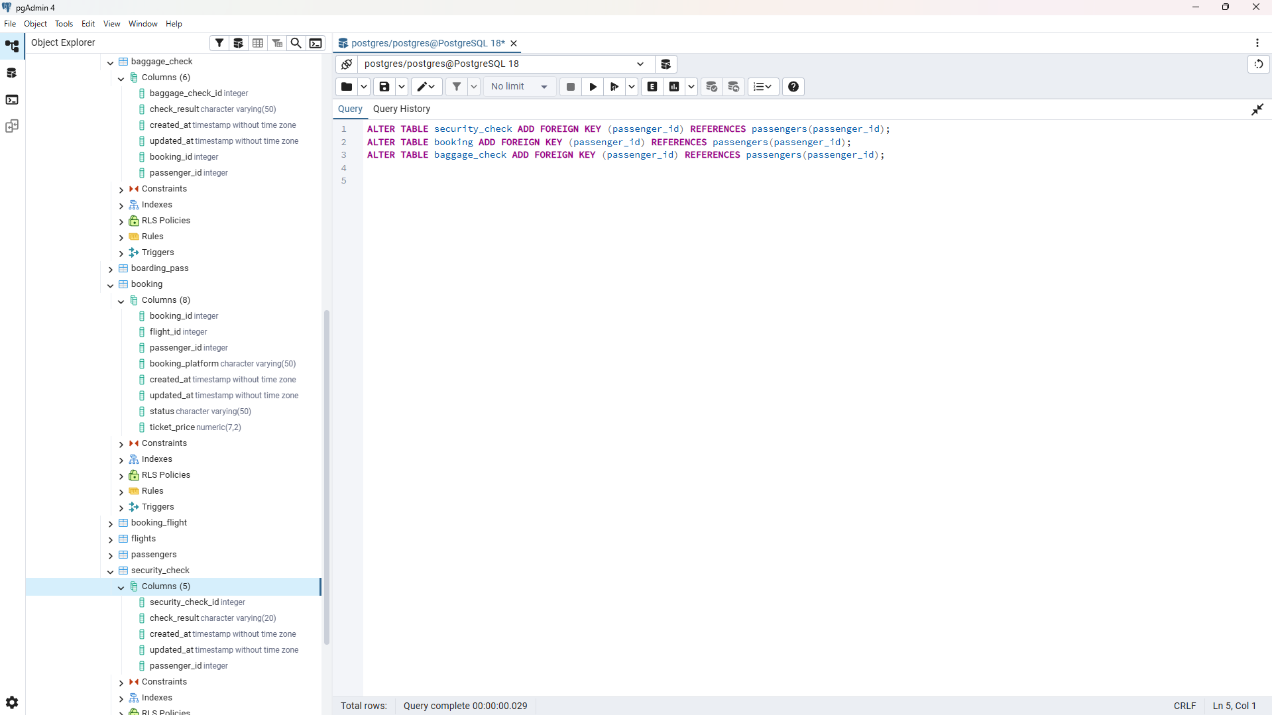
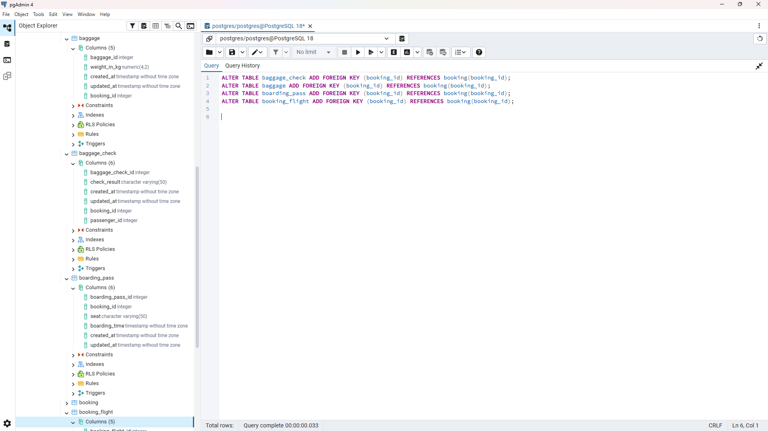
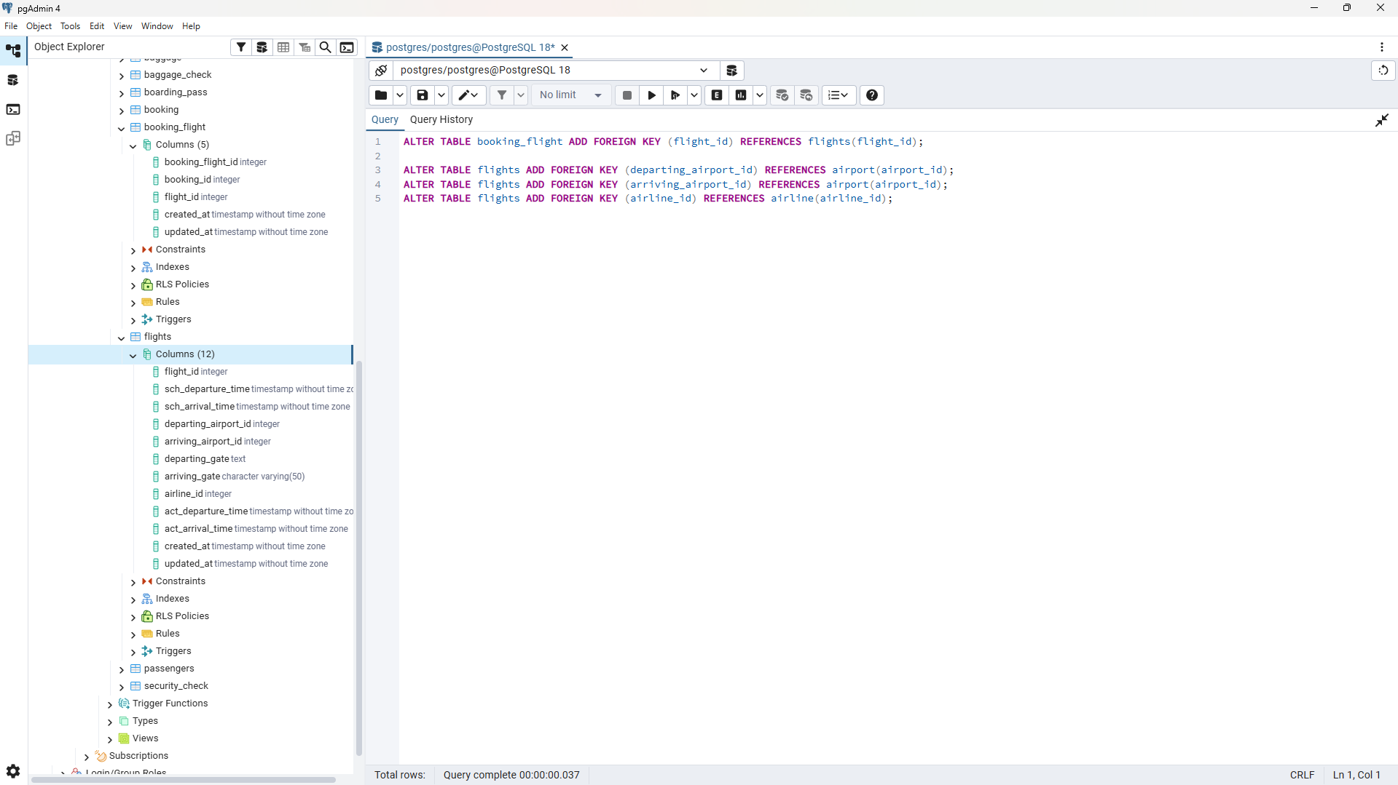

Normalization
“Booking_receipt (booking_id, passenger_full_name, passenger_passport_number, flight_number, departure_airport_name, departure_city, arrival_airport_name, arrival_city, airline_name, seat_numbers, ticket_price). The seat_numbers column stores a comma-separated list (e.g. "12A, 12B")”

1.Which normal form this table violates?
The Booking_receipt table violates First Normal Form. The reason is that the seat_numbers column stores a comma-separated list of seats ( "12A, 12B"). A cell value must be atomic—that is, indivisible—whereas here, a single cell contains multiple values.
2.Normalizing to 1NF
Assumptions: one booking corresponds to one flight and one passenger; the price applies to the entire booking; the airport name uniquely identifies the city; the flight number uniquely identifies the route and the airline.
Booking_receipt_1NF(booking_id, seat_number, passenger_full_name, passenger_passport_number, flight_number, departure_airport_name, departure_city, arrival_airport_name, arrival_city, airline_name, ticket_price)
Первичный ключ: (booking_id, seat_number). Внешних ключей нет.
Normalizing to 2NF
We split the table into two. One contains the locations, and the other holds everything else.
Booking_seat(booking_id (FK → Booking), seat_number)
Booking(booking_id, passenger_full_name, passenger_passport_number, flight_number, departure_airport_name, departure_city, arrival_airport_name, arrival_city, airline_name, ticket_price)
Normalizing to 3NF
Booking has "chains":
booking - passport - passenger name;
booking - flight - airline and airports;
airport - city.
Because of this, "Almaty International Airport," "Astana," and "Air Astana" are repeated many times.

We move each such group into its own table. Instead of long names, we use short ids, while keeping references to them in the main table.

Passenger(passenger_id, full_name, passport_number)
Airline(airline_id, airline_name)
Airport(airport_id, airport_name, city)
Flight(flight_id, flight_number, (FK)departing_airport_id, (FK)arriving_airport_id, (FK)airline_id )
Booking(booking_id, (FK )passenger_id , (FK) flight_id , ticket_price)
Booking_seat((FK)booking_id, seat_number)
3.Functional dependencies
For step 1 (1NF):
(booking_id, seat_number) → entire row (composite key).

For step 2 (2NF), we extract dependencies on parts of the key:
booking_id → passenger_full_name, passenger_passport_number, flight_number, ticket_price
flight_number → departure_airport_name, arrival_airport_name, airline_name

For step 3 (3NF), we eliminate chains (transitive dependencies):
passenger_passport_number → passenger_full_name
flight_number → departure_airport_name, arrival_airport_name, airline_name
departure_airport_name → departure_city
arrival_airport_name → arrival_city

The primary key of the Flights table is `flight_id`.
Functional dependency: `flight_id` → `sch_departure_time`, `sch_arrival_time`, `departing_airport_id`, `arriving_airport_id`, `departing_gate`, `arriving_gate`, `airline_id`, `act_departure_time`, `act_arrival_time`, `created_at`, `updated_at`.

The columns `departing_airport_id`, `arriving_airport_id`, and `airline_id` are merely foreign keys—that is, references. All information describing an airport (name, country, city) and an airline (name, country) is stored in the Airport and Airline tables, not in Flights. No non-key attribute determines another non-key attribute; therefore, there are no transitive dependencies.

4.Check DDL
The primary key of the `Flights` table is `flight_id`. Knowing `flight_id` determines all other columns: `flight_id` - all attributes. The columns `departing_airport_id`, `arriving_airport_id`, and `airline_id` are merely references , while airport and airline names are stored in other tables. No non-key column determines another non-key column; therefore, there are no transitive dependencies. The `Flights` table is in 3NF.

5.Create (this part was difficult for me so I used ai assistant in order to know how to create new tables without changing dll ones)
